NAME: | Sarcol, Joshua | DATE: | 09/17/2023

PRACTICE EXERCISE # 3.1

LE3.11 Weekly Pay.
Create a program that asks for user’s yearly pay and displays his weekly pay.

Flowchart: Weekly Pay
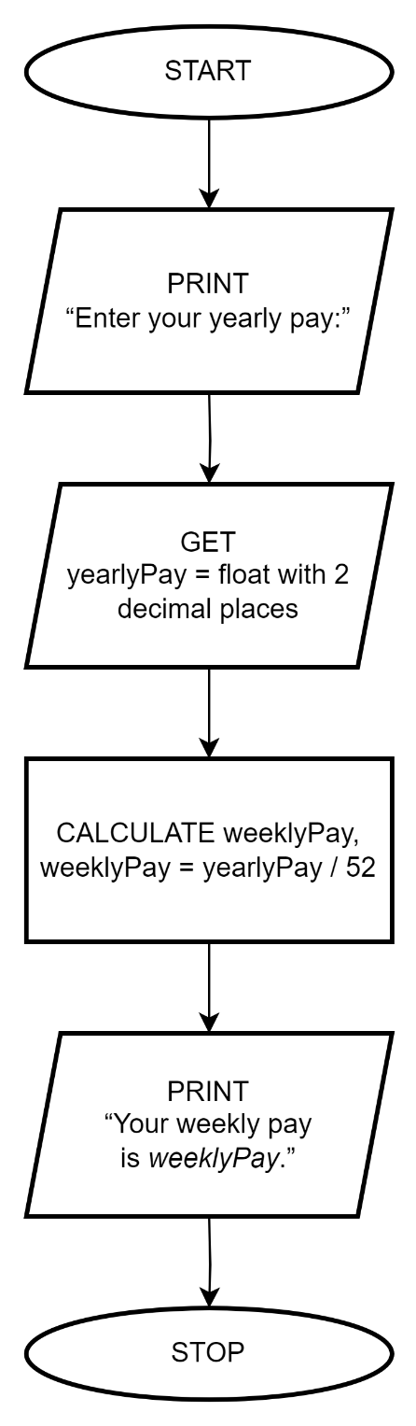

Pseudocode: Weekly Pay
START
1 | PRINT “Enter your yearly pay:”
2 | GET yearlyPay = float with 2 decimal places
3 | CALCULATE weeklyPay, weeklyPay = yearlyPay / 52
4 | PRINT “Your weekly pay is weeklyPay.”
STOP

C Code: Weekly Pay
#include <stdio.h>

int main ()
{
float yearlyPay;
printf("Enter your yearly pay: ");
scanf("%f", &yearlyPay);
float weeklyPay = yearlyPay/52;
printf("Your weekly pay is %.2f", weeklyPay);
return 0;
}

LE3.12 Add Digits.
Create a program that extracts and adds the two least significant digits of an integer.
Sample/Test Output
Enter a number : 12345
Sum : 4 + 5 = 9
===========================
Enter a number : 789
Sum : 8 + 9 = 17

Flowchart: Add digits
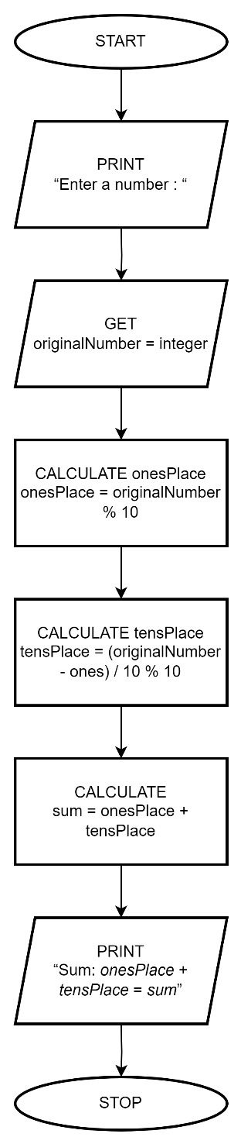

Pseudocode: Add digits
START
1 | PRINT “Enter a number : “
2 | GET originalNumber = integer
3 | CALCULATE onesPlace, onesPlace = originalNumber % 10
4 | CALCULATE tensPlace, tensPlace = (originalNumber - onesPlace) / 10 % 10
5 | CALCULATE sum = onesPlace + tensPlace
6 | PRINT “Sum : tensPlace + onesPlace = sum”
STOP

C Code: Add digits
#include <stdio.h>

int main ()
{
int originalNumber;
printf("Enter a number\t: ");
scanf("%d", &originalNumber);
int onesPlace = originalNumber % 10;
int tensPlace = (originalNumber - onesPlace) / 10 % 10;
int sum = onesPlace + tensPlace;
printf("Sum\t\t: %d + %d = %d", tensPlace, onesPlace, sum);
return 0;
}

LE3.13 Tuition Fee.
Create a program that prints the tuition for 2 semesters at ABC College. ABC charges PHP 450 for registration, plus PHP 450 per unit and a penalty of PHP 2,260 for each 12 units or fraction of 12.
Sample/Test Output
1st Semester Number of Units: 12
2nd Semester Number of Units: 25
1st Semester Tuition Fee : 8110.00
2nd Semester Tuition Fee : 16408.33
Total Tuition Fee : 24518.33

Flowchart: Tuition Fee
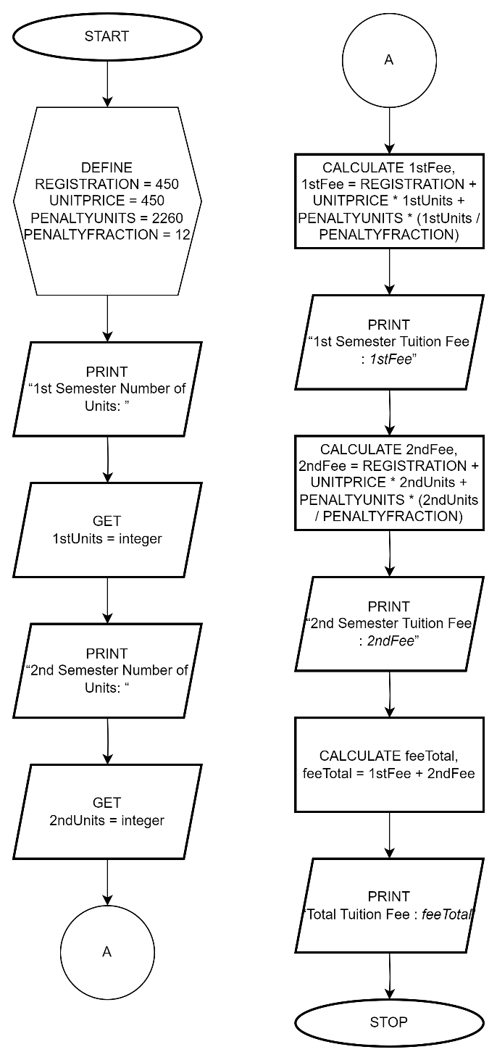

Pseudocode: Tuition Fee
START
1 | DEFINE REGISTRATION = 450
2 | DEFINE UNITPRICE = 450
3 | DEFINE PENALTYUNITS = 2260
4 | DEFINE PENALTYFRACTION = 12
5 | PRINT “1st Semester Number of Units: ”
6 | GET 1stUnits = number
7 | PRINT “2nd Semester Number of Units: “
8 | GET 2ndUnits = number
9 | CALCULATE 1stFee, 1stFee = REGISTRATION + UNITPRICE * 1stUnits + PENALTYUNITS * (1stUnits / PENALTYFRACTION)
10 | PRINT “1st Semester Tuition Fee : 1stFee”
11 | CALCULATE 2ndFee, 2ndFee = REGISTRATION + UNITPRICE * 2ndUnits + PENALTYUNITS * (2ndUnits / PENALTYFRACTION)
12 | PRINT “2nd Semester Tuition Fee : 2ndFee”
13 | CALCULATE feeTotal, feeTotal = 1stFee + 2ndFee
14 | PRINT “Total Tuition Fee : feeTotal”
STOP

C Code: Tuition Fee
#define REGISTRATION 450
#define UNITPRICE 450
#define PENALTYUNITS 2260
#define PENALTYFRACTION 12

#include <stdio.h>

int main ()
{
float firstUnits, secondUnits;
printf("1st Semester Number of Units\t: ");
scanf("%f", &firstUnits);
printf("2nd Semester Number of Units\t: ");
scanf("%f", &secondUnits);
float firstFee = REGISTRATION + UNITPRICE * firstUnits + PENALTYUNITS * (firstUnits / PENALTYFRACTION);
printf("1st Semester Tuition Fee\t: %7.2f\n", firstFee);
float secondFee = REGISTRATION + UNITPRICE * secondUnits + PENALTYUNITS * (secondUnits / PENALTYFRACTION);
printf("2nd Semester Tuition Fee\t: %7.2f\n", secondFee);
float feeTotal = firstFee + secondFee;
printf("Total Tuition Fee\t\t: %7.2f", feeTotal);
return 0;
}

